# EXPLORATORY ANALYSIS OF RAINFALL

# DATA IN INDIA FOR AGRICULTURE

## A PROJECT REPORT

***submitted by***

#### 

#### **VIGNESHWARI A** *732119205053*

#### **SATHIYA K** *732119205046*

#### **NANDHINI PRIYA T** 732119205029

#### **ANTHONY THOMAS R** 732119205005

#### 

### 

### TEAM ID: PNT2022TMID32283

**NANDHA COLLEGE OF TECHNOLOGY ,ERODE-52**

**DEPARTMENT OF INFORAMTION TECHNOLOGY**

### ANNA UNIVERSITY ,CHENNAI-600 025

### 

### TABLES OF CONTENTS

|  |  |
| --- | --- |
| S.NO | TITLE |
| 1. | **INTRODUCTION** |
| 1.1 | Project overview |
| 1.2 | purpose |
| **2** | **LITERATURE SURVEY** |
| 2.1 | Existing problem |
| 2.2 | References |
| 2.3 | Problem Statement Definition |
| **3** | **IDEATION & PROPOSED SOLUTION** |
| 3.1 | Empathy Map Canvas |
| 3.2 | Ideation and Brainstorming |
| 3.3 | Proposed Solution |
| 3.4 | Problem Soution Fit |
| **4** | **REQUIREMENT ANALYSIS** |
| 4.1 | Functional Requirements |
| 4.2 | Non-Functional Requirements |
| **5** | **PROJECT DESIGN** |
| 5.1 | Data Flow Diagrams |
| 5.2 | Solution & Technical Architecture |
| 5.3 | Users Stories |
| **6** | **PROJECT PLANNING & SCHEDULING** |
| 6.1 | Sprint Planning & Estimation |
| 6.2 | Sprint Delivery Schedule |
| 6.3 | Reports from JIRA |
| **7** | **CODING & SOLUTIONING** |
| 7.1 | Features |
| **8** | **TESTING** |
| 8.1 | Performance Testing |
| 8.2 | User Acceptance Testing |
| **9** | **RESULTS** |
| 9.1 | Performance Metrics |
| **10** | **CONCLUSION** |
| **11** | **FUTURE SCOPE** |
| **12** | **APPENDIX** |

**1 . INTRODUCTION**

**1.1 : Project Overview**

* The website is designed for farmers which is based on science and

technology to predict the condition of the atmosphere for a given location and

time.

* It is a statement saying what the weather will be like the next day or for the

next few days

* Accurate forecasting can help to save lives and minimize property damage

using machine learning

**1.2 : Purpose**

**T**he Purpose of this project is

* It can help with a farmers business decisions.
* Forecast's can help them plan for the many day to day decisions.This decisions include crop irrigation,time to fertilize ,and what days are suitable working in the field.
* The decisions that farmers make will result in a profitable crop or failure.
* The crop loses can be reduced substantially by affecting adjustments through timely and accurate weather forcasts.

**2 . LITERATURE SURVEY**

**2.1 : Existing Problem**

* Weather forcasting is the prediction of the state of the atmosphere for a

given location using the application of science and technology

* This includes temperature ,rain,cloudiness,wind speed and humidity.
* Weather warning are a special kind of short range forecast carried out for the

protection of human life.

* The forecast may be short range or long range.Its very interesting and

challenging task.

**2.2 : Problem Statement**

* Farmers need to check their Predicted data in the repective applications
* Farmers can put their certain date and location details that will calculate and

provide the probable chances.

* Farmers need this platform to get the idea about the weather data.It can

assist farmer determining when they should work most efficiently in the day to

day operations.

**3. IDEATION & PROPOSED SOLUTION**

**3.1 : Empathy Map Canvas**

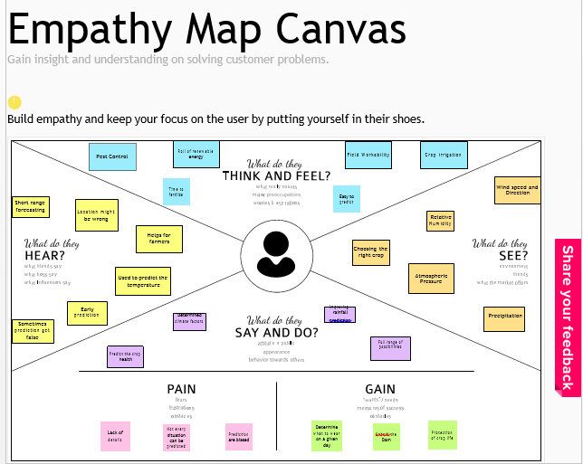

**3.2 : Ideation and Brainstorming**

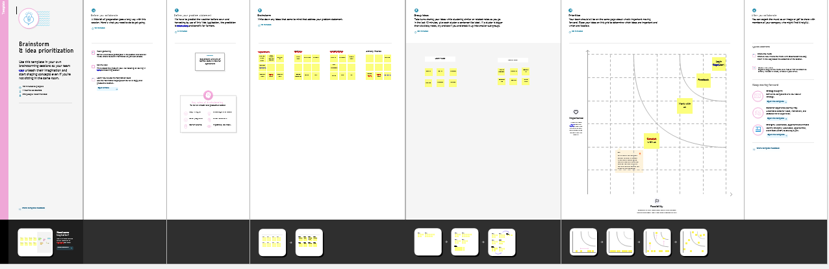

**3.3 : Proposed Solution**

**3.3 : Proposed Solution**

|  |  |  |
| --- | --- | --- |
| **S. No.** | **Parameter** | **Description** |
| 1. | Problem Statement (Problem to be solved) | Agriculture is highly dependent on weather conditions. Due to unpredictable rainfall there is a great impact in crop productivity. |
| 2. | Idea / Solution description | By analysing the pattern using the factors causing rainfall and determining the amount of rainfall in different locations, we can predict the rainfall. |
| 3. | Novelty / Uniqueness | Suggesting the type of crop to be harvested based on predicting the amount of rainfall |
| 4. | Social Impact/Customer Satisfaction | In Social Impact, it helps in making of decisions regarding the cropping pattern and sowing rate. |
| 5. | Business Model(Revenue Model) | Different types of crops can be planted for good health. It helps in making of decisions regarding the cropping pattern and sowing rate. |
| 6. | Scalability of the Solution | This will help the farmers in scheduling their agricultural process. A good balance of rain and proper irrigation can lead to faster growing plants and yields better crops |

**3.4 : Problem Solution Fit**

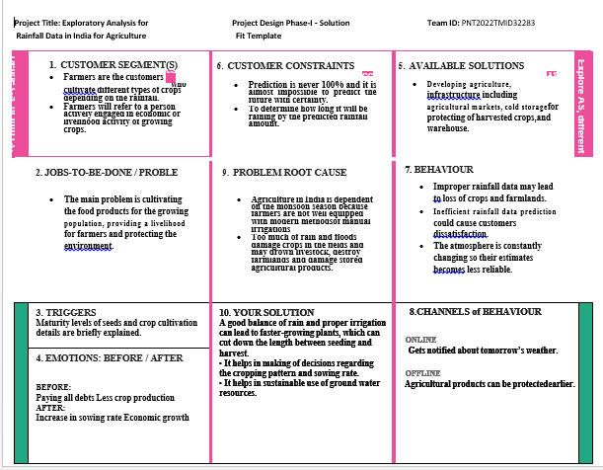**4.REQUIREMENT ANALYSIS**

**4.1 : Functional requirements**

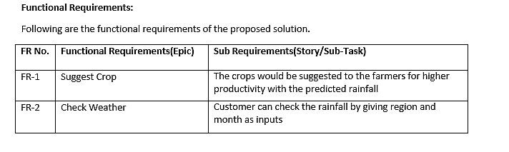

**4.2: Non-Functional requirements**

### 

### **5 . PROJECT DESIGN**

**5.1 : Data Flow Diagrams**

### 

**5.2 : Solution &Technical Architecture**

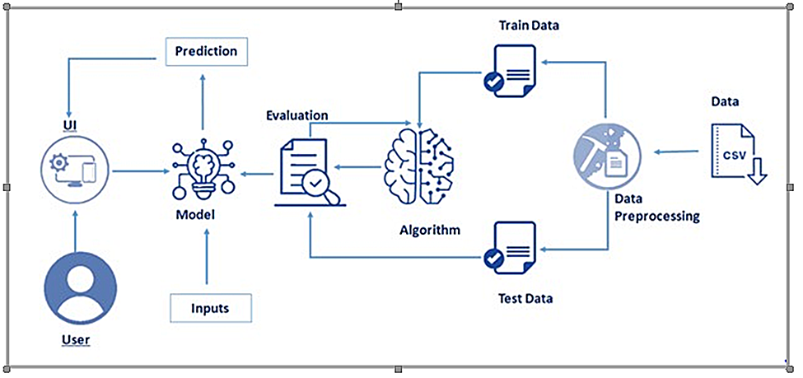

**5.3 : User Stories**

### **6 . PROJECT PLANNING & SCHEDULING**

**6.1 : Sprint Planning & Estimation**

### 

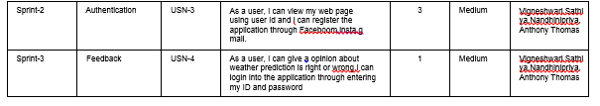

**6.2 : Sprint Delivery Schedule**

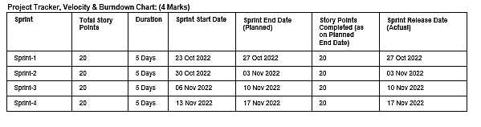

**6.3 : Reports From JIRA**

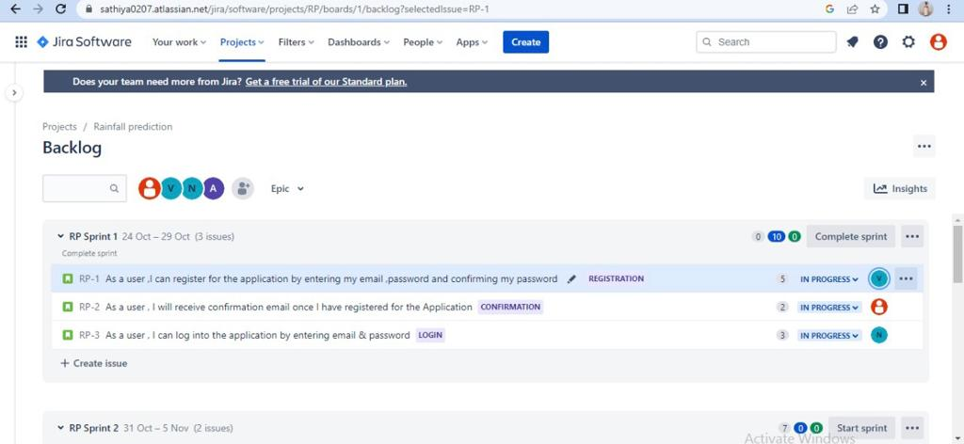

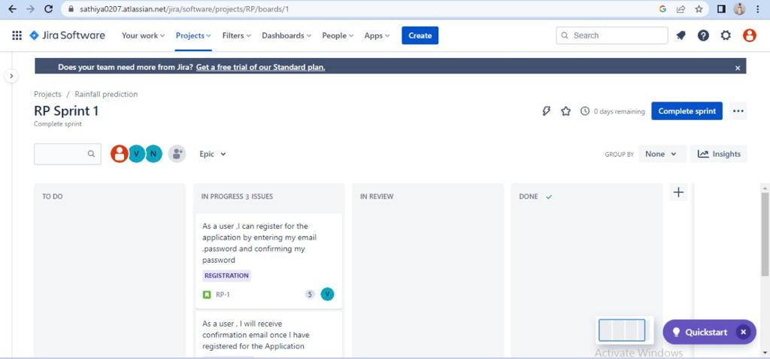

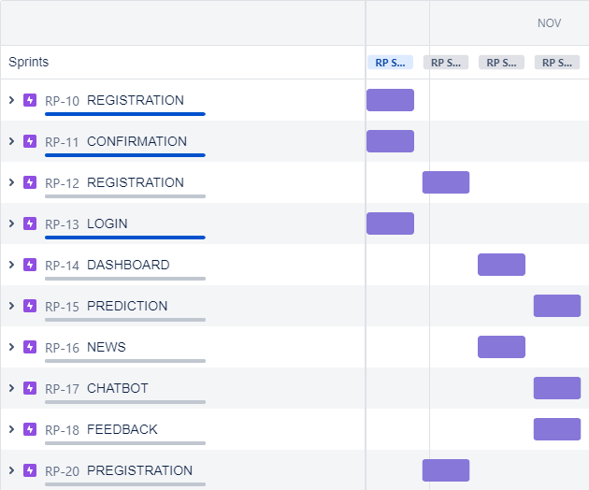

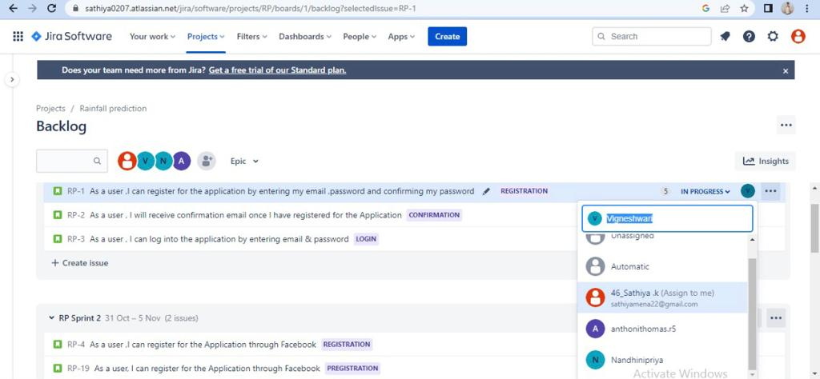

**7** . **CODING & SOLUTIONING**

### 7.1 Features

### Rainfall pediction

In features,we have designed a webpage using Hyper Text Markup Language(version 5)to predict the rainfall.The user can login into the webpage using username and password.After successful login,the user will be redirected to the home page.After entering into the home page,we have to choose the thing that we want.The choices are About,Contact us,News and Predictor.

### In our about page ,we loaded the information about prediction rate.In news page,the past and current information of weather forecasting is available.In Contact page,If customer have any queries that should be cleared through two ways-Feedback message and Direct contact.

In predictor page,We need to give certain location and Date,after submitting ,the predicted data will be displayed(chances of rainfall).In chatbot,we can select sowing month,the details of the suitable crops and harvesting period will be displayed.

### 

**LOGIN PAGE:**

### 

**SIGN UP PAGE:**

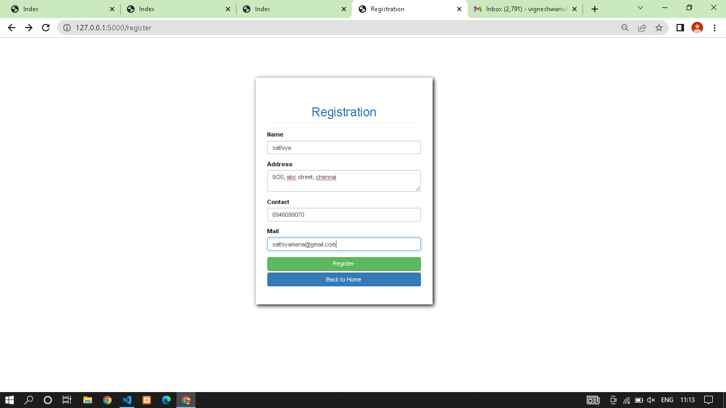

**HOME PAGE:**

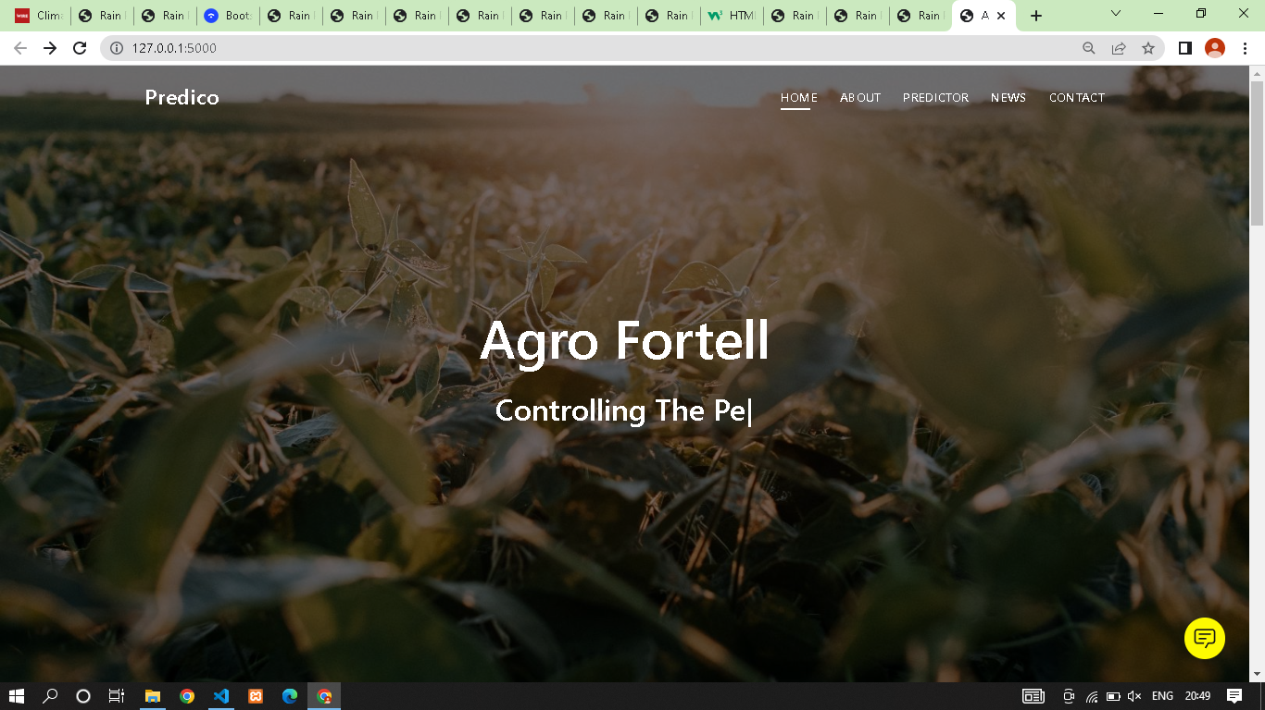

**ABOUT PAGE:**

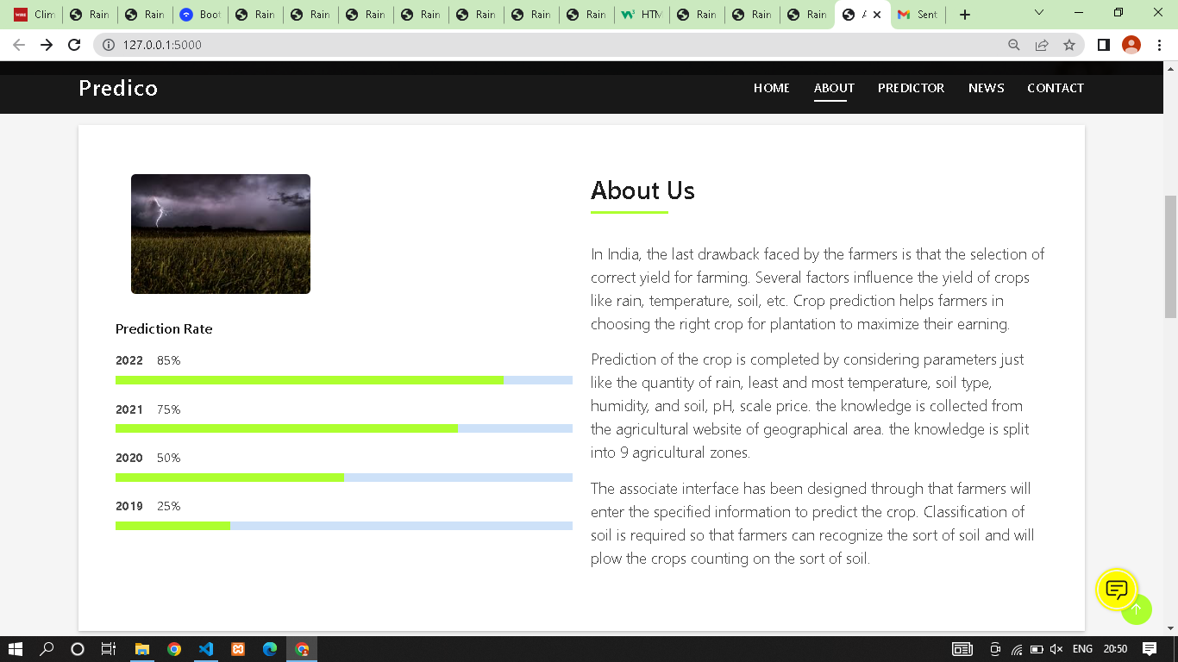

**NEWS PAGE:**

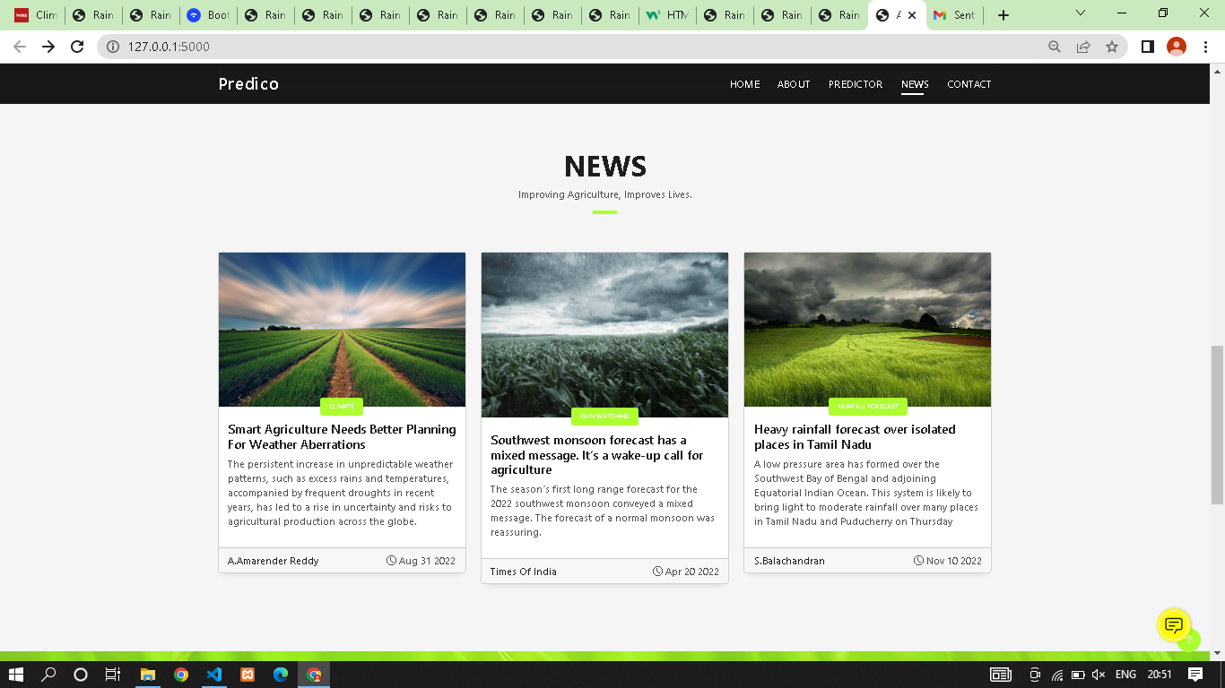

NEWS LINK PAGE 1:

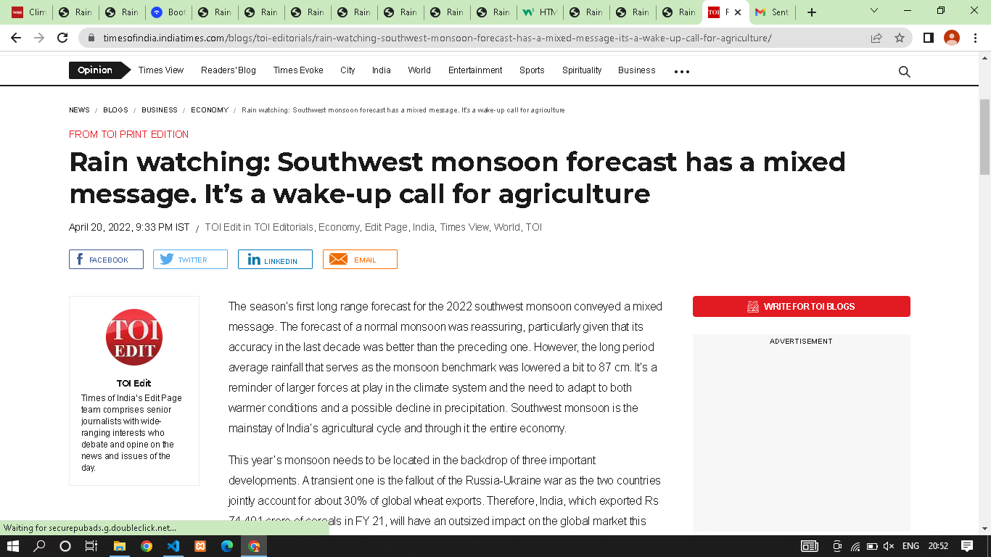

NEWS LINK PAGE 2:

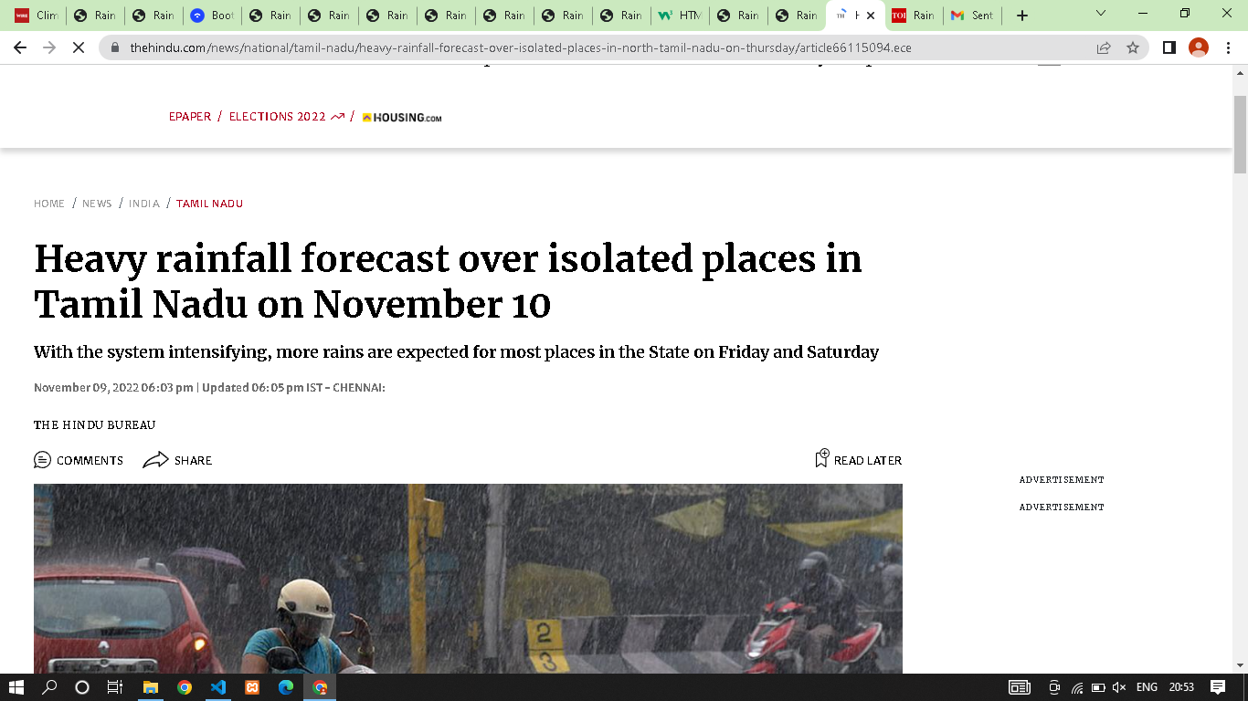

**CONTACT US PAGE:**

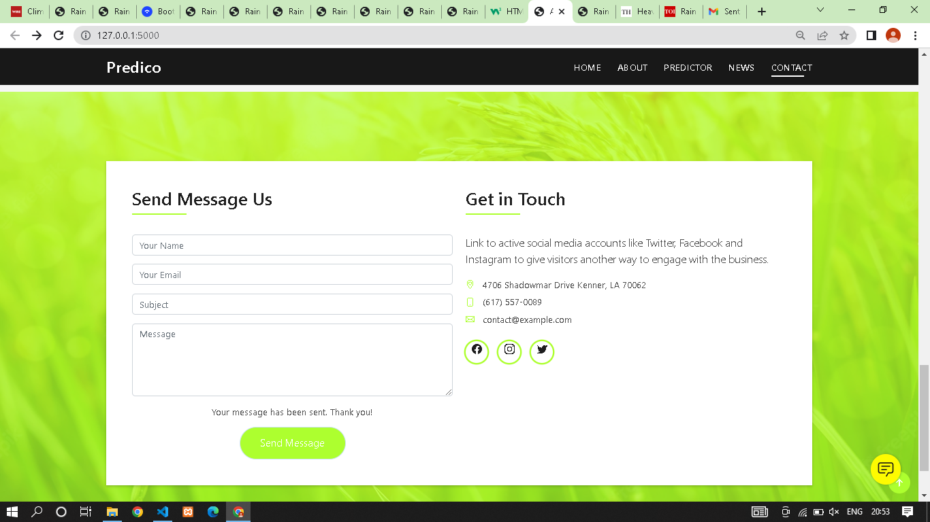

CONTACT US THROUGH FACEBOOK:

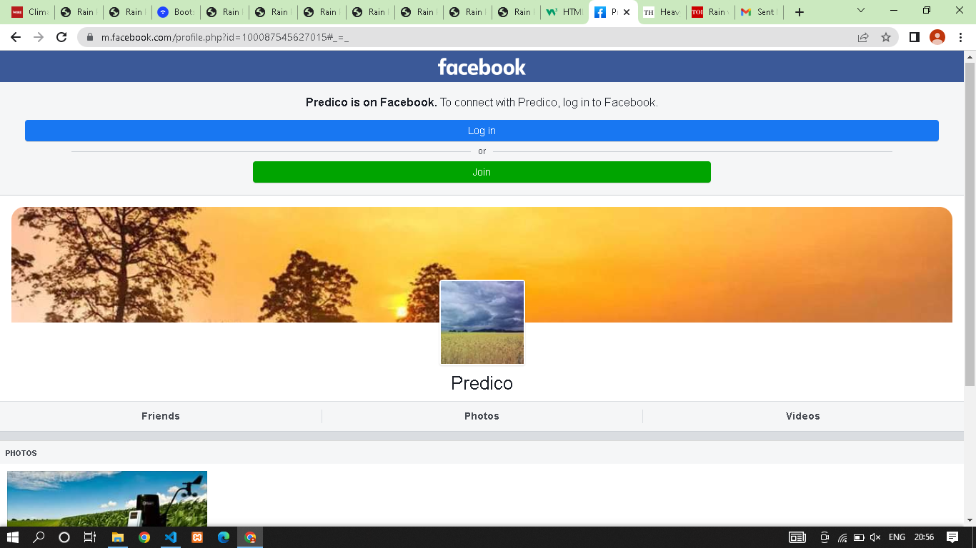

CONTACT US THROUGH INSTAGRAM:'

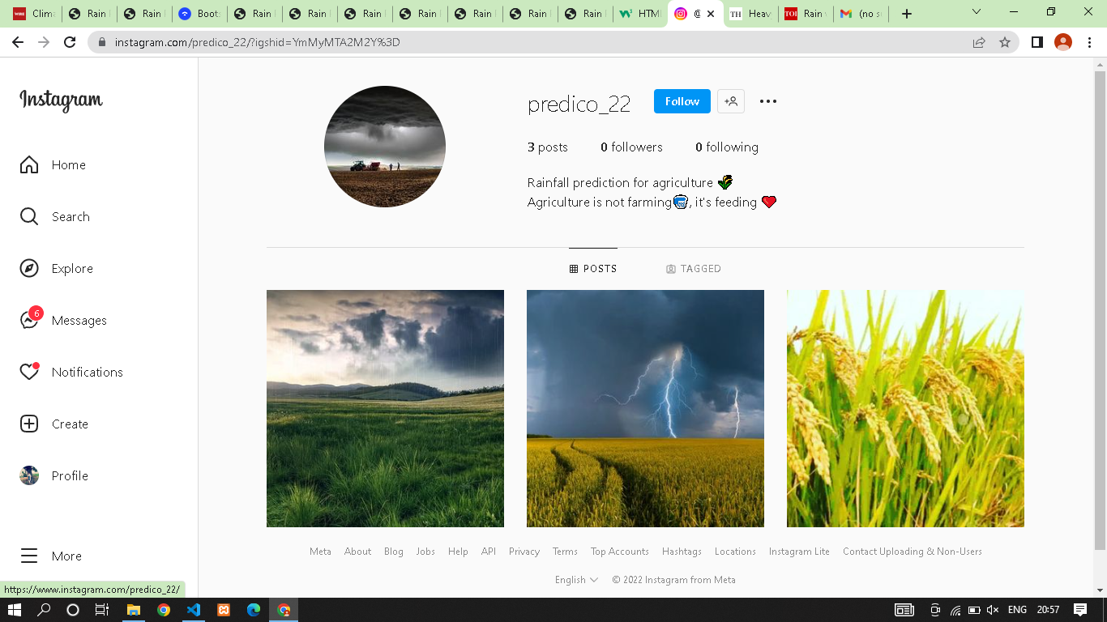

CONTACT US THROUGH TWITTER:

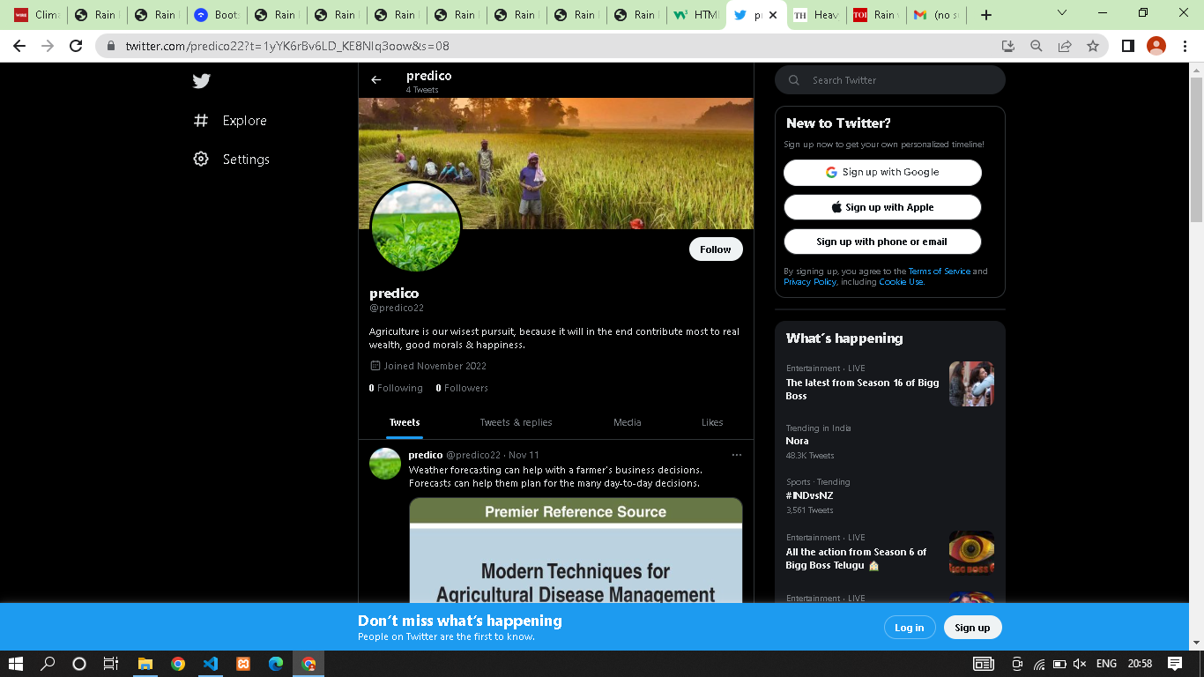

**PREDICTOR PAGE:**

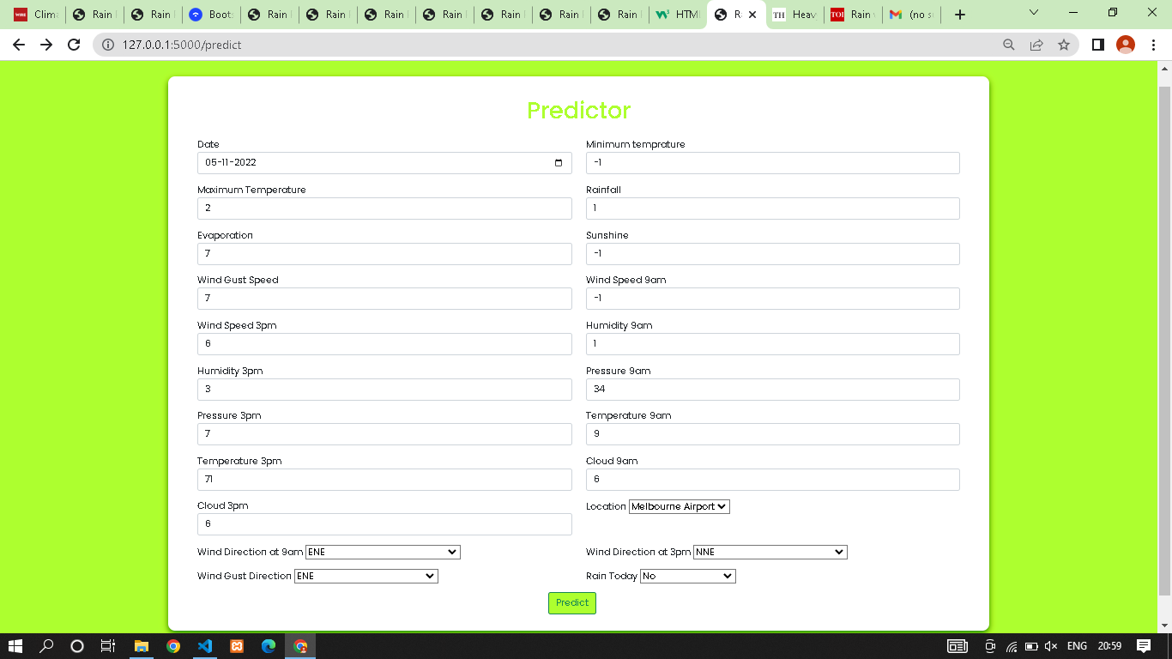

NO CHANCES OF RAINFALL PAGE:

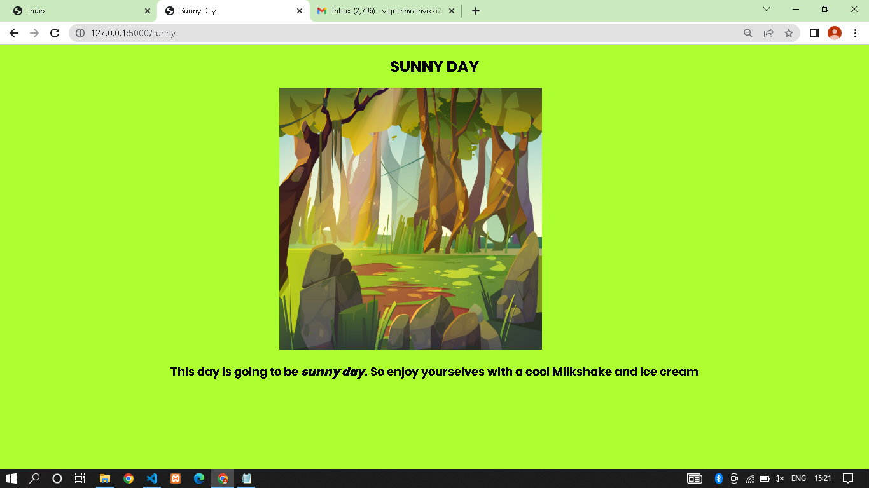

CHANCES OF RAINFALL PAGE:

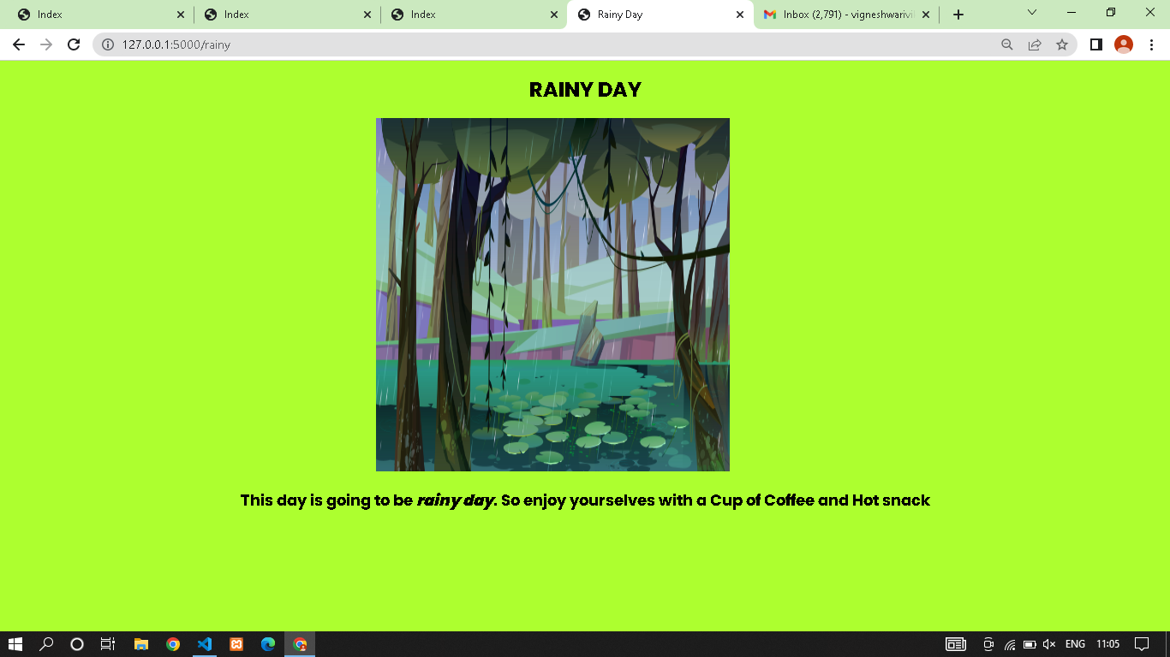

**PYTHON CODE FOR RAINFALL PREDICTION:**

**app.py**

import datetime  
import pickle  
import sqlite3  
  
import numpy as np  
import pandas as pd  
from flask import (Flask, flash, jsonify, redirect, render_template, request,  
 session, url_for)  
from flask_cors import cross_origin  
  
app = Flask(__name__, template_folder="templates")  
app.secret_key="vicky"  
model = pickle.load(open("models/cat.pkl", "rb"))  
print("Model Loaded")  
  
con=sqlite3.connect("database.db")  
con.execute("create table if not exists user(pid integer primary key,name text,address text,contact integer,mail text)")  
con.close()  
  
@app.route("/",methods=['GET'])  
@cross_origin()  
def home():  
 if not session:  
 return redirect(url_for("login"))  
 return render_template("index.html")  
  
@app.route("/login", methods=['GET', 'POST'])  
@cross_origin()  
def login():  
 if request.method=='POST':  
 name=request.form['name']  
 password=request.form['password']  
 con=sqlite3.connect("database.db")  
 con.row_factory=sqlite3.Row  
 cur=con.cursor()  
 cur.execute("select * from user where name=? and mail=?",(name,password))  
 data=cur.fetchone()  
  
 if data:  
 session["name"]=data["name"]  
 session["mail"]=data["mail"]  
 return redirect("/")  
 else:  
 flash("Username and Password Mismatch","danger")  
  
 return render_template("login.html")  
  
@app.route('/register',methods=['GET','POST'])  
def register():  
 if request.method=='POST':  
 try:  
 name=request.form['name']  
 address=request.form['address']  
 contact=request.form['contact']  
 mail=request.form['mail']  
 con=sqlite3.connect("database.db")  
 cur=con.cursor()  
 cur.execute("insert into user(name,address,contact,mail)values(?,?,?,?)",(name,address,contact,mail))  
 con.commit()  
 flash("Record Added Successfully","success")  
 except:  
 flash("Error in Insert Operation","danger")  
 finally:  
 con.close()  
 return redirect(url_for("login"))  
  
 return render_template('register.html')  
  
@app.route("/index",methods=['GET', 'POST'])  
@cross_origin()  
def index():  
 if not session:  
 return redirect(url_for("login"))  
 if request.method == "POST":  
# DATE  
 date = request.form['date']  
 day = float(pd.to_datetime(date, format="%Y-%m-%dT").day)  
 month = float(pd.to_datetime(date, format="%Y-%m-%dT").month)  
# MinTemp  
   
 minTemp = float(request.form['mintemp'])  
# MaxTemp  
 maxTemp = float(request.form['maxtemp'])  
# Rainfall  
 rainfall = float(request.form['rainfall'])  
# Evaporation  
 evaporation = float(request.form['evaporation'])  
# Sunshine  
 sunshine = float(request.form['sunshine'])  
# Wind Gust Speed  
 windGustSpeed = float(request.form['windgustspeed'])  
# Wind Speed 9am  
 windSpeed9am = float(request.form['windspeed9am'])  
# Wind Speed 3pm  
 windSpeed3pm = float(request.form['windspeed3pm'])  
# Humidity 9am  
 humidity9am = float(request.form['humidity9am'])  
# Humidity 3pm  
 humidity3pm = float(request.form['humidity3pm'])  
# Pressure 9am  
 pressure9am = float(request.form['pressure9am'])  
# Pressure 3pm  
 pressure3pm = float(request.form['pressure3pm'])  
# Temperature 9am  
 temp9am = float(request.form['temp9am'])  
# Temperature 3pm  
 temp3pm = float(request.form['temp3pm'])  
# Cloud 9am  
 cloud9am = float(request.form['cloud9am'])  
# Cloud 3pm  
 cloud3pm = float(request.form['cloud3pm'])  
# Cloud 3pm  
 location = float(request.form['location'])  
# Wind Dir 9am  
 winddDir9am = float(request.form['winddir9am'])  
# Wind Dir 3pm  
 winddDir3pm = float(request.form['winddir3pm'])  
# Wind Gust Dir  
 windGustDir = float(request.form['windgustdir'])  
# Rain Today  
 rainToday = float(request.form['raintoday'])  
 input_lst = [location , minTemp , maxTemp , rainfall , evaporation , sunshine ,  
windGustDir , windGustSpeed , winddDir9am , winddDir3pm , windSpeed9am , windSpeed3pm ,  
humidity9am , humidity3pm , pressure9am , pressure3pm , cloud9am , cloud3pm , temp9am , temp3pm ,  
rainToday , month , day]  
  
 pred = model.predict(input_lst)  
 output = pred  
 if output == 0:  
 return redirect(url_for("sunny"))  
 else:  
 return redirect(url_for("rainy"))  
 return render_template("predictor.html")  
  
@app.route("/predict")  
def predictor():  
 if not session:  
 return redirect(url_for("login"))  
 return render_template('predictor.html')  
  
@app.route("/sunny")  
def sunny():  
 if not session:  
 return redirect(url_for("login"))  
 return render_template('after_sunny.html')  
  
@app.route("/rainy")  
def rainy():  
 if not session:  
 return redirect(url_for("login"))  
 return render_template('after_rainy.html')  
  
@app.route('/logout')  
def logout():  
 session.clear()  
 return redirect(url_for("login"))  
  
if __name__=='__main__':  
app.run(debug=True)

**CHAT BOT :**

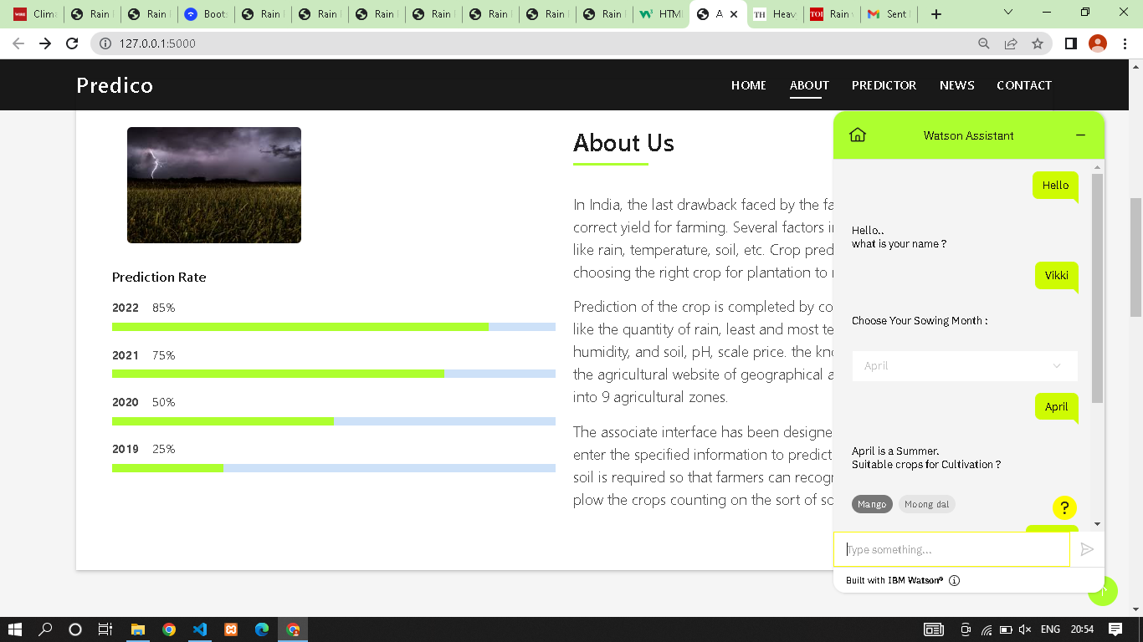

**8.Testing**

**8.1 Performance Testing**

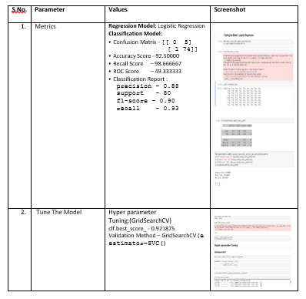

**8.2 User Acceptance Testing**

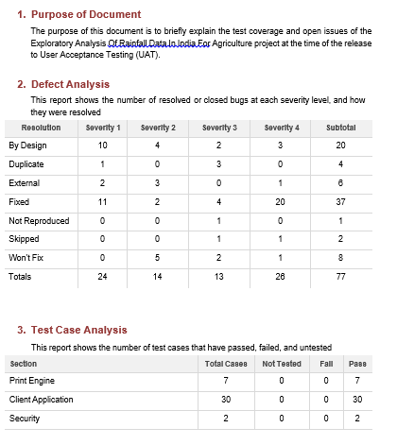

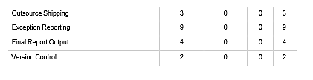

**9. RESULTS**

**9.1 Performance Metrics**

Software quality is a measurement of something intangible, “how good” a software product really is. Some of the aspects of so ftware

quality taken are

a. Scalability

b. Speed

c. Stability

d. Reliability

e. Security

f. Maintainability and code quality

**LOAD TEST**

|  |  |
| --- | --- |
| Scenario Name | Load Test – Exploratory Analysis of Rainfall Data in India for Agriculture |
| Scenario Type | Load Test – Duration 1 hour |
| Scenario Objective | To Simulate the peak load and to monitor the performance of the Website |
| Steps | The online load will be maintained at steady state |
| Entry Criteria | The online load will be maintained at steady state |
| Exit Criteria | The online load will be maintained at steady state |

**STRESS TEST**

|  |  |
| --- | --- |
| Scenario Name | Stress Test - Exploratory Analysis of Rainfall Data in India for Agriculture |
| Scenario Type | Stress Test |
| Scenario Objective | Objective is to verify that the application can handle the projected growth and to discover the breaking point |
| Steps | Ramp up to 150% of peak volume and continuously increase load until breaking point |
| Entry Criteria | All the monitors are in place Test Data is set up Peak load test completed successfully |
| Exit Criteria | Test completion report is agreed upon as per expectation |

**ENDURANCE / SOAK TEST:**

|  |  |
| --- | --- |
| Scenario Name | Soak Test - Exploratory Analysis of Rainfall Data in India for Agriculture |
| Scenario Type | Endurance – Duration 8 hours |
| Scenario Objective | To discover memory issues and bottlenecks that might occur under daily usage of the application |
| Steps | Steady state is maintained for 8 hours with half of the peak load |
| Entry Criteria | All the monitors are in place  Test Data is set up  Peak load test completed successfully |
| Exit Criteria | Test completion report is agreed upon as per expectation |

**10. ADVANTAGES :**

* Being able to forecast and plan for future when it comes to the local climate.
* Weather monitoring can be cut costs, product higher crop yields,and prevent over or under water.
* Sensors allow farmers to make better decisions about pesticides,watering and preventing diseases.
* Forecast's based on temperature and precipitation are imporatnt to agriculture,and therefore to traders within commodity markets.

**DISADVANTAGES:**

* Forecast's are never completely accurate-Forecast's are never 100% and it is almost impossible to predict the future with certainity.
* Problems concern availability,timeliness,and quality of observational data;time constraints on forecast preparation;the nature and reliability of communication system available for forecast
* Meterologists need to track multiple conditions and variables at the same time across vast areas,and many of these variables interact and affect one another.

**11. CONCLUSION**

* This Website gives accurate weather data it can assist farmers in determining when they should work most efficiently in the day to day life.
* It helps in controlling the pests and other crop diseases to spread over the feild .
* Weather factors can influences crop destroying pests.Weather forecast is defined as prediction of weather for the next few days to follow.

**12.FUTURE SCOPE**

* The demand for weather and climate forecast information in support of critical decision making has grown rapidly during the last decade and will grow even faster in coming years.
* Great Advances have been made in the utilisation of prediction in many areas of human activites.
* Weather forecast is the prediction of the state of the atmosphere for a given location using this website.
* Using this website ,weather warning can be identified .It is a special kind of short range forecast carried out for the protection of human life

**13. APPENDIX**

**Source Code:**

**login.html**

<!DOCTYPE html>  
<html lang="en">  
<head>  
 <meta charset="UTF-8">  
 <title>Index</title>  
 <link rel="stylesheet" href="{{url_for('static',filename='css/bootstrap.min.css')}}">  
 <link rel="stylesheet" href="{{url_for('static',filename='myfont/css/all.min.css')}}">  
 <script src="{{url_for('static',filename='js/jquery.min.js')}}"></script>  
 <style>  
 .shadow{  
 box-shadow:3px 3px 10px black;  
 padding:30px;  
 }  
 </style>  
</head>  
<body>  
 <!-- <img src="background.jpg" width="100%" height="100%"> -->  
 <div class="container" style="margin-top:100px">  
 <div class="col-md-offset-1 col-md-10" >  
 <div class="col-md-offset-3 col-md-5">  
 <div class="shadow">  
 <form action="/login" method="POST" autocomplete="off">  
 <h3 class="page-header text-primary">Login</h3>  
  
 {% with messages = get_flashed_messages(with_categories=true) %}  
 {% if messages %}  
 {% for category,message in messages %}  
 <div class="alert alert-{{category}}">{{message}}</div>  
 {% endfor %}  
 {% endif %}  
 {% endwith %}  
  
 <div class="form-group">  
 <label>Username</label>  
 <input type="text" name="name" class="form-control" required>  
 </div>  
 <div class="form-group">  
 <label>Password</label>  
 <input type="password" name="password" class="form-control" required>  
 </div>  
 <div class="form-group">  
 <input type="submit" value="Login" class="btn btn-success btn-block">  
 <a href="{{url_for('register')}}" class="btn btn-primary btn-block">Register</a>  
 </div>  
 </form>  
 </div>  
 </div>  
 </div>  
 </div>  
</body>  
</html>  
<script>  
 $(document).ready(function(){  
 $(".alert").hide(3000)  
 });  
</script>

**index.html**

<!DOCTYPE html>  
<html lang="en">  
  
<head>  
 <meta charset="utf-8">  
 <meta content="width=device-width, initial-scale=1.0" name="viewport">  
  
 <title>Agro Fortell</title>  
 <meta content="" name="description">  
 <meta content="" name="keywords">  
  
 <link href="static/vendor/bootstrap/css/bootstrap.min.css" rel="stylesheet">  
 <link href="static/vendor/bootstrap-icons/bootstrap-icons.css" rel="stylesheet">  
 <link href="static/vendor/glightbox/css/glightbox.min.css" rel="stylesheet">  
 <link href="static/vendor/swiper/swiper-bundle.min.css" rel="stylesheet">  
  
  
 <link rel="stylesheet" href="static/css/style.css">  
  
  
</head>  
  
<body>  
  
 <script>  
 window.watsonAssistantChatOptions = {  
 integrationID: "9a9d28f3-442b-4c51-bc82-488b1e485b94", // The ID of this integration.  
 region: "au-syd", // The region your integration is hosted in.  
 serviceInstanceID: "7db4f5ab-cdff-4050-96ba-40a4902b639f", // The ID of your service instance.  
 onLoad: function (instance) { instance.render(); }  
 };  
 setTimeout(function () {  
 const t = document.createElement('script');  
 t.src = "<https://web-chat.global.assistant.watson.appdomain.cloud/versions/>" + (window.watsonAssistantChatOptions.clientVersion || 'latest') + "/WatsonAssistantChatEntry.js";  
 document.head.appendChild(t);  
 });  
 </script>  
  
 <!-- ======= Header ======= -->  
 <header id="header" class="fixed-top">  
 <div class="container d-flex align-items-center justify-content-between">  
  
 <h1 class="logo"><a href="templates/index.html">Predico</a></h1>  
 <!-- Uncomment below if you prefer to use an image logo -->  
 <!-- <a href="index.html" class="logo"><img src="assets/img/logo.png" alt="" class="img-fluid"></a>-->  
  
 <nav id="navbar" class="navbar">  
 <ul>  
 <li><a class="nav-link scrollto active" href="#hero">Home</a></li>  
 <li><a class="nav-link scrollto" href="#about">About</a></li>  
 <li><a class="nav-link scrollto" href="/predict">Predictor</a></li>  
 <li><a class="nav-link scrollto " href="#news">News</a></li>  
 <li><a class="nav-link scrollto" href="#contact">Contact</a></li>  
 <li><a class="nav-link scrollto" href="{{url_for('logout')}}">Logout</a></li>  
 </ul>  
  
 <i class="bi bi-list mobile-nav-toggle"></i>  
 </nav><!-- .navbar -->  
  
 </div>  
 </header><!-- End Header -->  
  
 <!-- ======= Hero Section ======= -->  
 <div id="hero" class="hero route bg-image" style="background-image: url(static/img/mai.jpg)">  
 <div class="overlay-itro"></div>  
 <div class="hero-content display-table">  
 <div class="table-cell">  
 <div class="container">  
 <h1 class="hero-title mb-4">Agro Fortell</h1>  
 <p class="hero-subtitle"><span class="typed" data-typed-items="Controlling The Pests,  
 Plan For Future, Increased Productivity, Minimize Property Damage"></span></p>  
 <!-- <p class="pt-3"><a class="btn btn-primary btn js-scroll px-4" href="#about" role="button">Learn More</a></p> -->  
 </div>  
 </div>  
 </div>  
 </div><!-- End Hero Section -->  
  
 <main id="main">  
  
 <!-- ======= About Section ======= -->  
 <section id="about" class="about-mf sect-pt4 route">  
 <div class="container">  
 <div class="row">  
 <div class="col-sm-12">  
 <div class="box-shadow-full">  
 <div class="row">  
 <div class="col-md-6">  
 <div class="row">  
 <div class="col-sm-6 col-md-5">  
 <div class="about-img">  
 <img src="static/img/a-3.jpg" class="img-fluid rounded b-shadow-a"  
 alt="">  
 </div>  
 </div>  
 <div class="col-sm-6 col-md-7">  
 </div>  
 </div>  
 <div class="skill-mf">  
 <p class="title-s">Prediction Rate</p>  
  
 <div class="progress">  
 <div class="progress-bar" role="progressbar" style="width: 85%;"  
 aria-valuenow="85" aria-valuemin="0" aria-valuemax="100"></div>  
 </div>  
  
 <div class="progress">  
 <div class="progress-bar" role="progressbar" style="width: 75%"  
 aria-valuenow="75" aria-valuemin="0" aria-valuemax="100"></div>  
 </div>  
  
 <div class="progress">  
 <div class="progress-bar" role="progressbar" style="width: 50%"  
 aria-valuenow="50" aria-valuemin="0" aria-valuemax="100"></div>  
 </div>  
  
 <div class="progress">  
 <div class="progress-bar" role="progressbar" style="width: 25%"  
 aria-valuenow="25" aria-valuemin="0" aria-valuemax="100"></div>  
 </div>  
 </div>  
 </div>  
 <div class="col-md-6">  
 <div class="about-me pt-4 pt-md-0">  
 <div class="title-box-2">  
 <h5 class="title-left">  
 About Us  
 </h5>  
 </div>  
 <p class="lead">  
 In India, the last drawback faced by the farmers is that the selection of  
 correct  
 yield for farming. Several factors influence the yield of crops like rain,  
 temperature, soil, etc.  
 Crop prediction helps farmers in choosing the right crop for plantation to  
 maximize their earning.  
 </p>  
 <p class="lead">  
 Prediction of the crop is completed by  
 considering parameters just like the quantity of rain, least and most  
 temperature, soil type, humidity,  
 and soil, pH, scale price. the knowledge is collected from the agricultural  
 website of geographical area. the knowledge is split into 9 agricultural  
 zones.  
 </p>  
 <p class="lead">  
 The associate interface has been designed through that farmers  
 will enter the specified information to predict the crop. Classification of  
 soil is  
 required so that farmers can recognize the sort  
 of soil and will plow the crops counting on the sort of soil.  
 </p>  
 </div>  
 </div>  
 </div>  
 </div>  
 </div>  
 </div>  
 </div>  
 </section><!-- End About Section -->  
  
  
 <!-- ======= Blog Section ======= -->  
 <section id="news" class="blog-mf sect-pt4 route">  
 <div class="container">  
 <div class="row">  
 <div class="col-sm-12">  
 <div class="title-box text-center">  
 <h3 class="title-a">  
 News  
 </h3>  
 <p class="subtitle-a">  
 Improving Agriculture, Improves Lives.  
 </p>  
 <div class="line-mf"></div>  
 </div>  
 </div>  
 </div>  
 <div class="row">  
 <div class="col-md-4">  
 <div class="card card-blog">  
 <div class="card-img">  
 <!-- <a href="blog-single.html"> -->  
 <img src="static/img/a.jpg" alt="" class="img-fluid">  
 </div>  
 <div class="card-body">  
 <div class="card-category-box">  
 <div class="card-category">  
 <h6 class="category">Climate</h6>  
 </div>  
 </div>  
 <a  
 href="https://thewire.in/agriculture/climate-smart-agriculture-predicting-weather#:~:text=Climate%2DSmart%20Agriculture%20Needs%20Better%20Planning%20For%20Weather%20Aberrations,-agriculture&text=The%20persistent%20increase%20in%20unpredictable,agricultural%20production%20across%20the%20globe.">  
 <h3 class="card-title">Smart Agriculture Needs Better Planning For  
 Weather Aberrations</h3>  
 </a>  
 <p class="card-description">  
 The persistent increase in unpredictable weather patterns, such as excess rains and  
 temperatures, accompanied by frequent droughts in recent years,  
 has led to a rise in uncertainty and risks to agricultural production across the  
 globe.  
 </p>  
 </div>  
 <div class="card-footer">  
 <div class="post-author">  
 <a href="#">  
 <span class="author">A.Amarender Reddy</span>  
 </a>  
 </div>  
 <div class="post-date">  
 <span class="bi bi-clock"></span> Aug 31 2022  
 </div>  
 </div>  
 </div>  
 </div>  
 <div class="col-md-4">  
 <div class="card card-blog">  
 <div class="card-img">  
 <img src="static/img/a-1.jpg" alt="" class="img-fluid">  
 </div>  
 <div class="card-body">  
 <div class="card-category-box">  
 <div class="card-category">  
 <h6 class="category">Rain watching</h6>  
 </div>  
 </div>  
 <a  
 href="<https://timesofindia.indiatimes.com/blogs/toi-editorials/rain-watching-southwest-monsoon-forecast-has-a-mixed-message-its-a-wake-up-call-for-agriculture/>">  
 <h3 class="card-title">Southwest monsoon forecast has a  
 mixed message. It’s a wake-up call for agriculture</h3>  
 </a>  
 <p class="card-description">  
 The season’s first long range forecast for the 2022 southwest monsoon conveyed a  
 mixed message.  
 The forecast of a normal monsoon  
 was reassuring.  
 </p>  
 </div>  
 <div class="card-footer">  
 <div class="post-author">  
 <a href="#">  
 <span class="author">Times Of India</span>  
 </a>  
 </div>  
 <div class="post-date">  
 <span class="bi bi-clock"></span> Apr 20 2022  
 </div>  
 </div>  
 </div>  
 </div>  
 <div class="col-md-4">  
 <div class="card card-blog">  
 <div class="card-img">  
 <img src="static/img/a-2.jpg" alt="" class="img-fluid">  
 </div>  
 <div class="card-body">  
 <div class="card-category-box">  
 <div class="card-category">  
 <h6 class="category">Rainfall Forecast</h6>  
 </div>  
 </div>  
 <a  
 href="<https://www.thehindu.com/news/national/tamil-nadu/heavy-rainfall-forecast-over-isolated-places-in-north-tamil-nadu-on-thursday/article66115094.ece>">  
 <h3 class="card-title">Heavy rainfall forecast over isolated places in Tamil Nadu  
 </h3>  
 <p class="card-description">  
 </a>  
 A low pressure area has formed over the Southwest Bay of Bengal and  
 adjoining Equatorial Indian Ocean. This system is likely to bring  
 light to moderate rainfall over many places in Tamil Nadu and Puducherry on Thursday  
 </p>  
 </div>  
 <div class="card-footer">  
 <div class="post-author">  
 <a href="#">  
 <span class="author">S.Balachandran</span>  
 </a>  
 </div>  
 <div class="post-date">  
 <span class="bi bi-clock"></span> Nov 10 2022  
 </div>  
 </div>  
 </div>  
 </div>  
 </div>  
 </div>  
 </section><!-- End Blog Section -->  
  
 <!-- ======= Contact Section ======= -->  
 <section id="contact" class="paralax-mf footer-paralax bg-image sect-mt4 route"  
 style="background-image: url(static/img/b1.webp)">  
 <div class="overlay-mf"></div>  
 <div class="container">  
 <div class="row">  
 <div class="col-sm-12">  
 <div class="contact-mf">  
 <div id="contact" class="box-shadow-full">  
 <div class="row">  
 <div class="col-md-6">  
 <div class="title-box-2">  
 <h5 class="title-left">  
 Send Message Us  
 </h5>  
 </div>  
 <div>  
 <form action="forms/contact.php" method="post" role="form"  
 class="php-email-form">  
 <div class="row">  
 <div class="col-md-12 mb-3">  
 <div class="form-group">  
 <input type="text" name="name" class="form-control"  
 id="name" placeholder="Your Name" required>  
 </div>  
 </div>  
 <div class="col-md-12 mb-3">  
 <div class="form-group">  
 <input type="email" class="form-control" name="email"  
 id="email" placeholder="Your Email" required>  
 </div>  
 </div>  
 <div class="col-md-12 mb-3">  
 <div class="form-group">  
 <input type="text" class="form-control" name="subject"  
 id="subject" placeholder="Subject" required>  
 </div>  
 </div>  
 <div class="col-md-12">  
 <div class="form-group">  
 <textarea class="form-control" name="message" rows="5"  
 placeholder="Message" required></textarea>  
 </div>  
 </div>  
 <div class="col-md-12 text-center my-3">  
 <div class="error-message"></div>  
 <div class="sent-message">Your message has been sent. Thank you!  
 </div>  
 </div>  
 <div class="col-md-12 text-center">  
 <button type="submit"  
 class="button button-a button-big button-rouded">Send  
 Message</button>  
 </div>  
 </div>  
 </form>  
 </div>  
 </div>  
 <div class="col-md-6">  
 <div class="title-box-2 pt-4 pt-md-0">  
 <h5 class="title-left">  
 Get in Touch  
 </h5>  
 </div>  
 <div class="more-info">  
 <p class="lead">  
 Link to active social media accounts like Twitter, Facebook and  
 Instagram  
 to give visitors another way to engage with the business.  
 </p>  
 <ul class="list-ico">  
 <li><span class="bi bi-geo-alt"></span> 4706 Shadowmar Drive Kenner, LA  
 70062</li>  
 <li><span class="bi bi-phone"></span> (617) 557-0089</li>  
 <li><span class="bi bi-envelope"></span> [contact@example.com](mailto:contact@example.com)</li>  
 </ul>  
 </div>  
 <div class="socials">  
 <ul>  
 <!-- <div class="card-img">  
 <a href="blog-single.html"><img src="assets/img/a.jpg" alt="" class="img-fluid"></a>  
 </div> -->  
 <li><a href="<https://m.facebook.com/profile.php?id=100087545627015#_=_>"><span  
 class="ico-circle"><i class="bi bi-facebook"></i></span></a>  
 </li>  
 <li><a href="<https://instagram.com/predico_22?igshid=YmMyMTA2M2Y=>"><span  
 class="ico-circle"><i  
 class="bi bi-instagram"></i></span></a></li>  
 <li><a  
 href="<https://twitter.com/predico22?t=1yYK6rBv6LD_KE8NIq3oow&s=08>"><span  
 class="ico-circle"><i class="bi bi-twitter"></i></span></a>  
 </li>  
 </ul>  
 </div>  
 </div>  
 </div>  
 </div>  
 </div>  
 </div>  
 </div>  
 </div>  
 </section><!-- End Contact Section -->  
  
 </main><!-- End #main -->  
  
  
  
 <div id="preloader"></div>  
 <a href="#" class="back-to-top d-flex align-items-center justify-content-center"><i  
 class="bi bi-arrow-up-short"></i></a>  
  
 <!-- Vendor JS Files -->  
 <script src="static/vendor/purecounter/purecounter_vanilla.js"></script>  
 <script src="static/vendor/bootstrap/js/bootstrap.bundle.min.js"></script>  
 <script src="static/vendor/glightbox/js/glightbox.min.js"></script>  
 <script src="static/vendor/swiper/swiper-bundle.min.js"></script>  
 <script src="static/vendor/typed.js/typed.min.js"></script>  
 <script src="static/vendor/php-email-form/validate.js"></script>  
  
 <!-- Template Main JS File -->  
 <script src="static/js/main.js"></sc  
</body>  
</html>

**predictor.html**

<!DOCTYPE html>  
<html lang="en">  
  
<head>  
 <meta charset="UTF-8">  
 <meta http-equiv="X-UA-Compatible" content="IE=edge">  
 <meta name="viewport" content="width=device-width, initial-scale=1.0">  
 <link rel="preconnect" href="[https://fonts.gstatic.com](https://fonts.gstatic.com/)">  
 <link href="<https://fonts.googleapis.com/css2?family=Poppins:wght@100;400;500;600;700;800;900&display=swap>"  
 rel="stylesheet">  
 <link href="<https://cdn.jsdelivr.net/npm/bootstrap@5.0.0-beta2/dist/css/bootstrap.min.css>" rel="stylesheet"  
 integrity="sha384-BmbxuPwQa2lc/FVzBcNJ7UAyJxM6wuqIj61tLrc4wSX0szH/Ev+nYRRuWlolflfl" crossorigin="anonymous">  
 <link rel="stylesheet" href="{{url_for('static',filename='predictor.css')}}">  
 <title>Rain Prediction</title>  
 <style>  
 body {  
 /* background-color: greenyellow; */  
 font-family: 'Poppins', sans-serif;  
 }  
  
 .btn-outline-success {  
 background-color: greenyellow;  
 }  
  
 .form {  
 background-color: white;  
 width: 70vw;  
 margin: 50px auto;  
 padding: 20px 50px;  
 box-shadow: 0 5px 11px 0 green, 0 4px 15px 0 yellow;  
 border-radius: 12px;  
 }  
  
 .form h1 {  
 color: greenyellow;  
 }  
 </style>  
</head>  
  
<body>  
  
 <section id="prediction-form" class="bg-image">  
 <form class="form" action="/index" method="POST">  
 <h1 class="my-3 text-center">Predictor</h1>  
 <div class="row">  
 <div class="col-md-6 my-2">  
 <div class="md-form">  
 <label for="date" class="date">Date</label>  
 <input type="date" class="form-control" id="date" name="date">  
 </div>  
 </div>  
 <div class="col-md-6 my-2">  
 <div class="md-form">  
 <label for="mintemp" class="mintemp"> Minimum temprature</label>  
 <input type="number" class="form-control" id="mintemp" name="mintemp">  
 </div>  
 </div>  
 <div class="col-md-6 my-2">  
 <div class="md-form">  
 <label for="maxtemp" class="maxtemp">Maximum Temperature</label>  
 <input type="number" class="form-control" id="maxtemp" name="maxtemp">  
 </div>  
 </div>  
 <div class="col-md-6 my-2">  
 <div class="md-form">  
 <label for="rainfall" class="rainfall">Rainfall</label>  
 <input type="number" class="form-control" id="rainfall" name="rainfall">  
 </div>  
 </div>  
 <div class="col-md-6 my-2">  
 <div class="md-form">  
 <label for="evaporation" class="evaporation">Evaporation</label>  
 <input type="number" class="form-control" id="evaporation" name="evaporation">  
 </div>  
 </div>  
 <div class="col-md-6 my-2">  
 <div class="md-form">  
 <label for="sunshine" class="sunshine">Sunshine</label>  
 <input type="number" class="form-control" id="sunshine" name="sunshine">  
 </div>  
 </div>  
 <div class="col-md-6 my-2">  
 <div class="md-form">  
 <label for="windgustspeed" class="windgustspeed">Wind Gust Speed</label>  
 <input type="number" class="form-control" id="windgustspeed" name="windgustspeed">  
 </div>  
 </div>  
 <div class="col-md-6 my-2">  
 <div class="md-form">  
 <label for="windspeed9am" class="windspeed9am">Wind Speed 9am</label>  
 <input type="number" class="form-control" id="windspeed9am" name="windspeed9am">  
 </div>  
 </div>  
 <div class="col-md-6 my-2">  
 <div class="md-form">  
 <label for="windspeed3pm" class="windspeed3pm">Wind Speed 3pm</label>  
 <input type="number" class="form-control" id="windspeed3pm" name="windspeed3pm">  
 </div>  
 </div>  
 <div class="col-md-6 my-2">  
 <div class="md-form">  
 <label for="humidity9am" class="humidity9am">Humidity 9am</label>  
 <input type="number" class="form-control" id="humidity9am" name="humidity9am">  
 </div>  
 </div>  
 <div class="col-md-6 my-2">  
 <div class="md-form">  
 <label for="humidity3pm" class="humidity3pm">Humidity 3pm</label>  
 <input type="number" class="form-control" id="humidity3pm" name="humidity3pm">  
 </div>  
 </div>  
 <div class="col-md-6 my-2">  
 <div class="md-form">  
 <label for="pressure9am" class="pressure9am">Pressure 9am</label>  
 <input type="number" class="form-control" id="pressure9am" name="pressure9am">  
 </div>  
 </div>  
 <div class="col-md-6 my-2">  
 <div class="md-form">  
 <label for="pressure3pm" class="pressure3pm">Pressure 3pm</label>  
 <input type="number" class="form-control" id="pressure3pm" name="pressure3pm">  
 </div>  
 </div>  
  
 <div class="col-md-6 my-2">  
 <div class="md-form">  
 <label for="temp9am" class="temp9am">Temperature 9am</label>  
 <input type="number" class="form-control" id="temp9am" name="temp9am">  
 </div>  
 </div>  
 <div class="col-md-6 my-2">  
 <div class="md-form">  
 <label for="temp3pm" class="temp3pm">Temperature 3pm</label>  
 <input type="number" class="form-control" id="temp3pm" name="temp3pm">  
 </div>  
 </div>  
 <div class="col-md-6 my-2">  
 <div class="md-form">  
 <label for="cloud9am" class="cloud9am">Cloud 9am</label>  
 <input type="number" class="form-control" id="cloud9am" name="cloud9am">  
 </div>  
 </div>  
 <div class="col-md-6 my-2">  
 <div class="md-form">  
 <label for="cloud3pm" class="cloud3pm">Cloud 3pm</label>  
 <input type="number" class="form-control" id="cloud3pm" name="cloud3pm">  
 </div>  
 </div>  
 <div class="col-md-6 my-2">  
 <div class="md-form">  
 <label for="location" class="location" name="location">Location</label>  
 <select class="location" id="location" name="location" aria-label="Location">  
 <option selected>Select Location</option>  
 <option value=24>Adelaide</option>  
 <option value=7>Albany</option>  
 <option value=30>Albury</option>  
 <option value=46>AliceSprings</option>  
 <option value=33>BadgerysCreek</option>  
 <option value=14>Ballarat</option>  
 <option value=36>Bendigo</option>  
 <option value=21>Brisbane</option>  
 <option value=2>Cairns</option>  
 <option value=43>Cobar</option>  
 <option value=9>CoffsHarbour</option>  
 <option value=4>Dartmoor</option>  
 <option value=11>Darwin</option>  
 <option value=15>GoldCoast</option>  
 <option value=17>Hobart</option>  
 <option value=45>Katherine</option>  
 <option value=23>Launceston</option>  
 <option value=28>Melbourne</option>  
 <option value=25>Melbourne Airport</option>  
 <option value=44>Mildura</option>  
 <option value=42>Moree</option>  
 <option value=5>MountGambier</option>  
 <option value=12>MountGinini</option>  
 <option value=19>Newcastle </option>  
 <option value=47>Nhil</option>  
 <option value=13>NorahHead</option>  
 <option value=6>NorfolkIsland</option>  
 <option value=32>Nuriootpa</option>  
 <option value=40>PearceRAAF</option>  
 <option value=31>Penrith</option>  
 <option value=26>Perth</option>  
 <option value=35>Perth Airport</option>  
 <option value=1>Portland</option>  
 <option value=37>Richmond</option>  
 <option value=27>Sale</option>  
 <option value=41>Salmon Gums</option>  
 <option value=10>Sydney</option>  
 <option value=16>Sydney Airport</option>  
 <option value=39>Townsville</option>  
 <option value=34>Tuggeranong</option>  
 <option value=49>Uluru</option>  
 <option value=38>WaggaWagga</option>  
 <option value=3>Walpole</option>  
 <option value=18>Watsonia</option>  
 <option value=22>William Town</option>  
 <option value=8>Witchcliffe</option>  
 <option value=20>Wollongong</option>  
 <option value=48>Woomera</option>  
 </select>  
 </div>  
 </div>  
 <div class="col-md-6 my-2">  
 <div class="md-form">  
 <label for="winddir9am" class="winddir9am" name="winddir9am">Wind Direction at 9am</label>  
 <select class="winddir9am" id="winddir9am" name="winddir9am" aria-label="Wind Direction 9am">  
 <option selected>Select Wind Direction at 9am</option>  
 <option value=1>N</option>  
 <option value=5>W</option>  
 <option value=10>S</option>  
 <option value=15>E</option>  
 <option value=2>NW</option>  
 <option value=9>NE</option>  
 <option value=7>SW</option>  
 <option value=13>SE</option>  
 <option value=0>NNW</option>  
 <option value=3>NNE</option>  
 <option value=8>SSW</option>  
 <option value=11>SSE</option>  
 <option value=4>WNW</option>  
 <option value=6>WSW</option>  
 <option value=12>ENE</option>  
 <option value=14>ESE</option>  
 </select>  
 </div>  
 </div>  
 <div class="col-md-6 my-2">  
 <div class="md-form">  
 <label for="winddir3pm" class="winddir3pm" name="winddir3pm">Wind Direction at 3pm</label>  
 <select class="winddir3pm" id="winddir3pm" name="winddir3pm" aria-label="Wind Direction at 3pm">  
 <option selected>Select Wind Direction at 3pm</option>  
 <option value=2>N</option>  
 <option value=4>W</option>  
 <option value=8>S</option>  
 <option value=14>E</option>  
 <option value=0>NW</option>  
 <option value=11>NE</option>  
 <option value=9>SW</option>  
 <option value=10>SE</option>  
 <option value=1>NNW</option>  
 <option value=5>NNE</option>  
 <option value=7>SSW</option>  
 <option value=12>SSE</option>  
 <option value=3>WNW</option>  
 <option value=6>WSW</option>  
 <option value=13>ENE</option>  
 <option value=15>ESE</option>  
 </select>  
 </div>  
 </div>  
 <div class="col-md-6 my-2">  
 <div class="md-form">  
 <label for="windgustdir" class="windgustdir" name="windgustdir">Wind Gust Direction</label>  
 <select class="windgustdir" id="windgustdir" name="windgustdir"  
 aria-label="Wind Gust Direction">  
 <option selected>Select Wind Gust Direction</option>  
 <option value=3>N</option>  
 <option value=4>W</option>  
 <option value=7>S</option>  
 <option value=15>E</option>  
 <option value=1>NW</option>  
 <option value=11>NE</option>  
 <option value=9>SW</option>  
 <option value=12>SE</option>  
 <option value=0>NNW</option>  
 <option value=6>NNE</option>  
 <option value=8>SSW</option>  
 <option value=10>SSE</option>  
 <option value=2>WNW</option>  
 <option value=5>WSW</option>  
 <option value=14>ENE</option>  
 <option value=13>ESE</option>  
 </select>  
 </div>  
 </div>  
 <div class="col-md-6 my-2">  
 <div class="md-form">  
 <label for="raintoday" class="raintoday" name="raintoday">Rain Today</label>  
 <select class="raintoday" id="raintoday" name="raintoday" aria-label="Rain Today">  
 <option selected>Did it Rain Today</option>  
 <option value=1>Yes</option>  
 <option value=0>No</option>  
 </select>  
 </div>  
 </div>  
 <div class="col-md-6 my-2 d-flex align-items-end justify-content-around">  
 <button type="submit" class="btn btn-outline-success" style="margin-left: 100%;"  
 id="button">Predict</button>  
 </div>  
 </div>  
 </form>  
 </section>  
 <div>  
 <h1>  
 <centre> {{ prediction }} </centre>  
 </h1>  
 </div>  
 <script src="<https://cdn.jsdelivr.net/npm/bootstrap@5.0.0-beta2/dist/js/bootstrap.bundle.min.js>"  
 integrity="sha384-b5kHyXgcpbZJO/tY9Ul7kGkf1S0CWuKcCD38l8YkeH8z8QjE0GmW1gYU5S9FOnJ0"  
 crossorigin="anonymous"></script>  
</body>  
  
</html>

**GITHUB LINK :**

**<https://github.com/IBM-EPBL/IBM-Project-14025-1659539083>**

**PROJECT DEMO LINK:**

**<https://drive.google.com/file/d/1FJUMZM_Mes2rCBbhqW7ZztaAsm6BecMC/view>**